Static and Dynamic Routing – Exploration & Verification

PART A – CONCEPTUAL GROUNDING
1.Static Routing
When we use static routing, we are telling the router exactly where to send packets for a particular network. The router does not “figure things out” on its own — it simply follows the instructions we give it.
This makes static routing very predictable. If traffic is going somewhere, we know exactly which path it will take because we defined it manually. However, this control also makes static routing fragile. If a link goes down or the network changes, the router does not adapt. It will continue trying to send packets along the same path, even if that path no longer exists.
Static routing makes sense in small, stable networks where:
- The topology rarely changes
- There are very few routers
- The administrator wants full control (for example, a small office or a backup route)
In short, static routing works well when humans can manage the network easily, but it does not scale well when the network grows.

2. Dynamic Routing
Dynamic routing changes the mindset completely. Instead of manually telling routers everything, we allow routers to exchange information with each other.
When dynamic routing is enabled:
- Routers learn about remote networks automatically
- Routing tables update on their own
- The network can adapt to failures
Dynamic routing protocols exist because manual control breaks down at scale. In large networks, it is impossible for a human to keep updating routes every time something changes.
Dynamic routing solves problems such as:
- Automatic discovery of new networks
- Faster recovery from link failures
- Reduced human error
Here, routers behave more like collaborating devices rather than passive machines waiting for instructions.
3. Static vs Dynamic
Static routing does not scale well because every change requires manual configuration. Dynamic routing scales easily as routers learn automatically.
Static routing fails silently and permanently until a human fixes it. Dynamic routing may briefly fail, but it recovers automatically.
Static routing requires high human effort over time, while dynamic routing requires initial configuration effort, after which the network largely manages itself.

PART B – STATIC ROUTING LAB (GNS3)

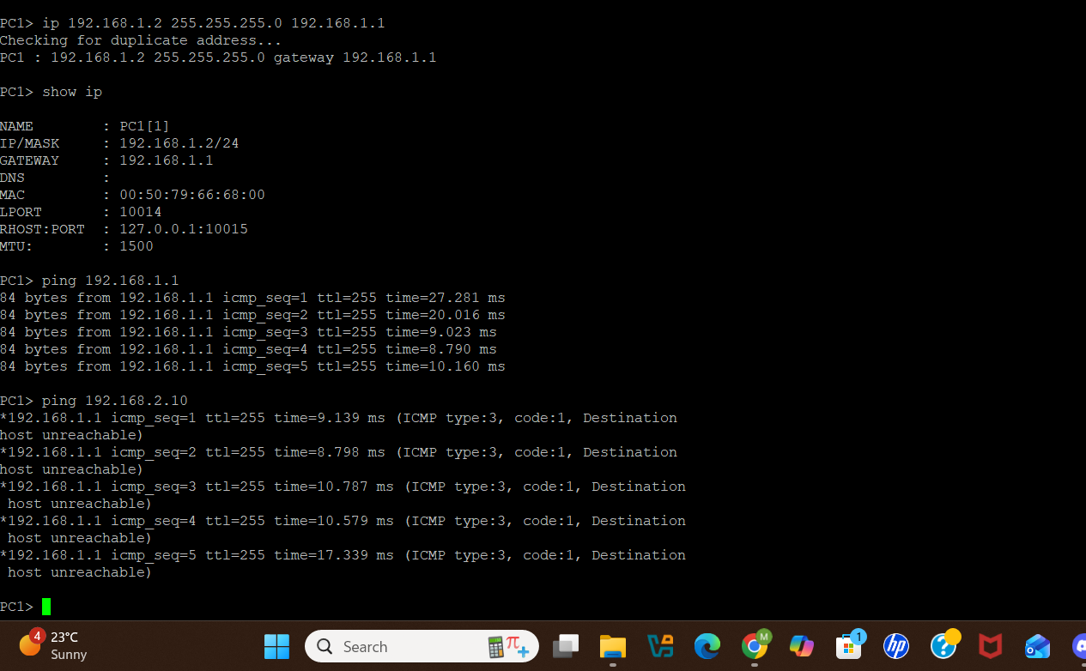

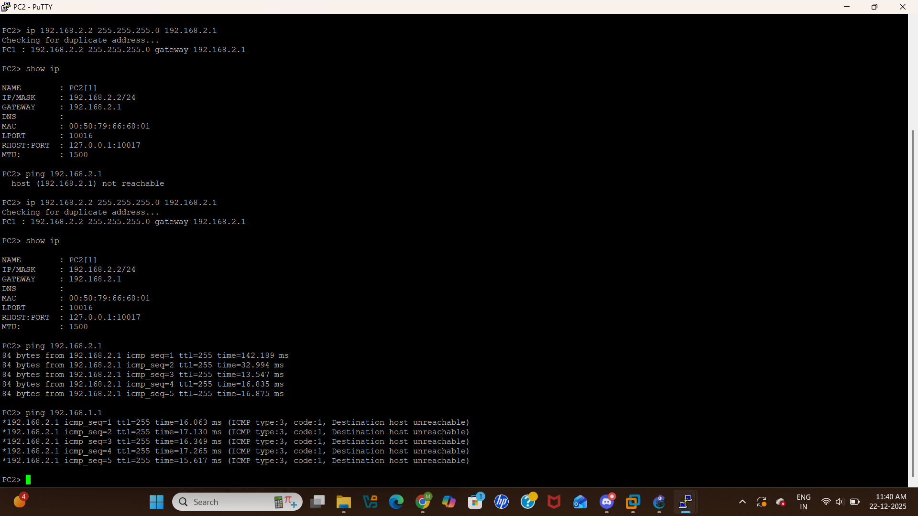

PART C
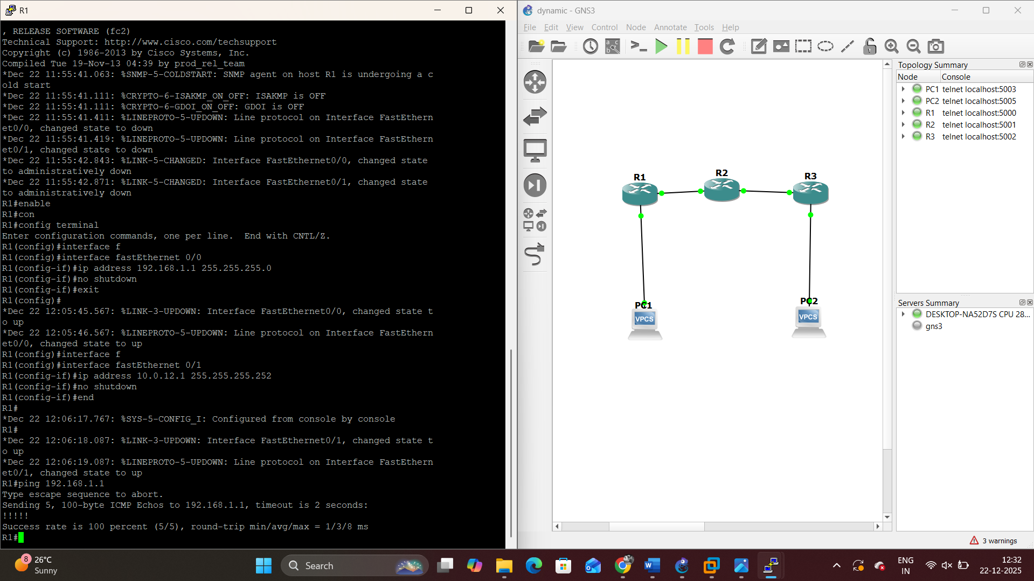

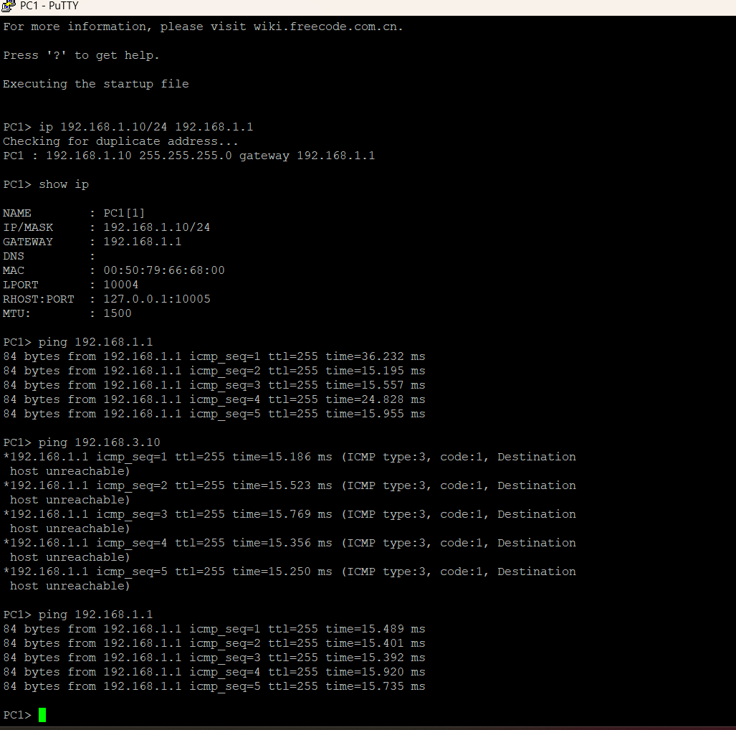

PART D Comparison of Static and Dynamic Routing

1. Routing Table Characteristics
In a static routing configuration, routing tables were minimal and manually populated. Routes remained constant and did not change unless edited by the network administrator. This resulted in a predictable but inflexible routing table.
Dynamic routing produced routing tables that were automatically learned and maintained. Routes included metrics and were updated regularly through routing protocol exchanges, allowing the table to reflect current network conditions.

2. Impact of Link Failure
During a link failure, static routing did not provide automatic recovery. The failed path remained in the routing table, causing traffic disruption until manual changes were applied.
With dynamic routing, routers identified the failure and removed the affected route. New paths were calculated, and traffic was rerouted through available alternatives without administrator intervention.

3. Network Adaptability
Dynamic routing appeared more responsive and adaptive, as the network reacted automatically to changes. Routing updates occurred continuously, making the system feel active and self-managing.
Static routing lacked this adaptability and required human intervention to respond to network changes.

4. Appropriate Use of Static Routing
Static routing is most effective in networks with simple topologies and minimal changes, such as small businesses or branch offices. It offers lower resource usage and increased control over routing paths.

5. Necessity of Dynamic Routing
Dynamic routing is necessary in complex and large-scale networks, including corporate networks and service provider environments. The ability to scale, provide redundancy, and recover quickly from failures makes dynamic routing essential.

